I. Program Name: Movie Reviewer

II. Program Description: A program that displays the users review for a movie.

III. Input/Process/Output:

Input:

* The users review
* The rating for each reviewer
* Choice whether to loop or not

Process: Create a loop t

Output: Display the reviews on the screen

IV. Flowchart:

V. Source Code:

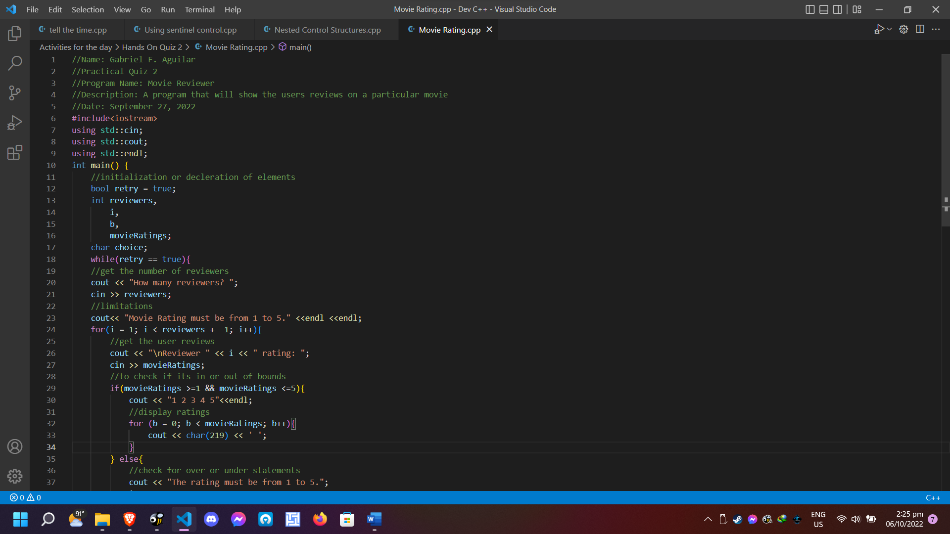

VI. Screenshot:



